

U.S. LNG Export to NATO Countries Arima Forecasting

Student: Duncan Ferguson

Class: Data Science Tools II

Instructor: Don Dalton

Date: 6/1/2022

Table of Contents

Introduction 3

Research Question 4

Data 4

Data Cleaning 5

Data Model 7

Appendix 8

Image 1. 8

Bibliography 8

Introduction

Thursday, February 24th will be a famous day in history. It is the day that Russia invaded Ukraine and quite possibly started WWIII. Or it could be argued that the start was on February 20th, 2014, when Russia launched a “special military operation” to annex Crimea. In fact, there are many pivotal moments in the relationship between the U.S., Western Europe and Russia, but those two stated will be the measure markers in which this paper conducts its research. More specifically, as the title states U.S. LNG exports to NATO countries is the focus.

In 2008 the EU 27 imported almost 38% of their natural gas from Russia. During that year, Richard Anderson from the Marshal Center forecasted that the percentage could even rise to 50-60% two decades later.[1] He wasn’t far off; “in 2021 the EU imported 155 billion cubic meters of natural gas from Russia, accounting for around 45% of EU gas imports and close to 40% of its total gas consumption.”[2] This is important because Russia’s oil and gas industry makes up a significant portion of its GDP. The Moscow times even put the figure at 60% of GDP in March of 2019.[3] The interdependency of this natural gas relationship has hamstringed Western Europe’s ability to implement effective sanctions.

While Western Europe currently pipes in natural Gas from Russia there are various other ways in which it can meet its current energy needs. To transport natural gas, it needs to be compressed into Liquified Natural Gas (LNG). Thankfully, the U.S. Shale Boom has provided the U.S. with an access of natural gas. Having gone from a net importer of natural gas to a net exporter of natural gas in recent years, opened the opportunity for the U.S. to supply Western Europe with an alternative source. While market forces determine how much gas has been shipped from the U.S. to Europe, analyzing the current trends offers an insight into what the future might hold.

Research Question

Did the U.S. ramp up exports to NATO countries after Russia ? What percentage of our LNG exports are being directed to NATO? Is that percentage increasing or decreasing?

Data

The data to be explored for this research project comes from the U.S. Energy Information Administration. The EIA produces a monthly report that details U.S. Natural Gas Exports by country with volumes measured in Million Cubic Feet (MMCF) at the following URL: <https://www.eia.gov/dnav/ng/ng_move_expc_s1_m.htm> . This web page offers a 6-month view on its home page with various links to dive deeper into the metrics.[4]

For this project the data the Juypter notebook has been set up to extract the most recent xls data sheet that has been embedded onto the home page. The webpage is accessed with selenium chromedriver. The driver file must be in the same folder as the notebook and must be a version that corresponds to the version of chrome that is installed on the computer running the notebook. In this case the driver corresponds to Chrome Version 102.0.5005.62.[5] When running the notebook, the user is prompted to select a file in which to save the excel file with the name “NG_MOVE_EXPC_S1_M.xls”.

This file contains U.S. Natural Gas Exports from January 1973 up to February 2022 at the time of this report being written. There are three different sheets. The first being an overview containing contact information and report release dates. The second sheet contains export columns and the third being export prices. The second sheet which is used for this project contains metrics on every U.S. export to every country and by which transportation method. It should be noted that most of the fields remain null until around August 2015.

The baseline of exports for the U.S. is to both Canada and Mexico via Pipeline. All the columns that possess null values, only possess nulls in earlier dates. Once a metric is recorded there are no intermediary nulls. The only exclusion is for U.S. Liquefied Natural Gas Exports to China where the U.S. exported 1127 mcf in May of 2011 and then not again until July 2016. It is for this reason that I have assumed that all the null values mean that the exports quantify as 0.

Data Cleaning

After the file is imported the table on sheet 1 is printed out to display the data’s basic descriptions such as: Description, # of series, frequency, and latest date uploaded. This is accomplished using a basic panda iloc. A function called LNG_Scrubber is created and takes in a data frame, an “others” option, and “na_graph” option. The “others” options enables the user to toggle between scrubbing data for exports to Japan, Israel, China, Russia, Taiwan and South Korea or exports to NATO countries. While the research question is primarily looking at NATO exports, it is always interesting to see how the U.S. is exporting to other countries of strategic importance. The na_graph it option allows for the user to visualize post scrubbing NaN values to ensure that they have been appropriately delt with.

The first actions that the LNG Scrubber enacts is displaying the head of the data so that the user can get a raw view of the file. The top two rows are dropped, and the column names are set to their real values. The date column is converted to datetime and set as the index. A blank column list is then generated so that it may be populated.

The function’s main purpose resides inside two for loops. These loops go through all the column names and determines if they are in the list of countries that is to be analyzed (as set by the “others” input) and by whether the column’s name includes ‘to’, ‘Re-Exports’, ‘Truck’, ‘Vessel’. The if statement is set up to exclude all countries not in the target list and all columns that do not contain Vessel. The one exception being U.S. Total export metrics. These were kept so that percentages of exports could be calculated. While the columns are being collected, the appropriate columns are being cast as type float64.

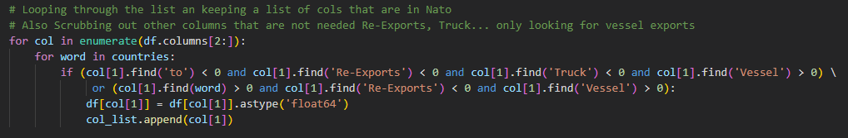

After the appropriate columns have been selected, the data frame is truncated to only include dates beyond January 1st, 2017. This date represents a point in time where the U.S. ramps up its natural gas exports and allows for a clean graph. All null values are set to 0 as it is assumed that the null value represents no natural exports during this time. A heatmap of null values is then printed to help display this transformation. For extra measures a description is printed out to display Dtypes and columns that have been selected. A “graphit” function is then created to help display graphs of the dataframe as it continues to get adjusted. The first graph of which displays U.S. Exports to NATO Countries. At first glance of image 1 in the appendix there is an alarming dip in the data caused by covid that may affect the Arima model.

Data Model

For the start of the Arima model all the NATO nations are rolled up into an aggregate field, then a 12-month rolling average is calculated for both total U.S. LNG exports and U.S. exports to only NATO countries. This is displayed in appendix image 2. The rolling average helps take out the variation and smooth over the graph. The effects of covid are still displayed but not as prominent. The next plots image 3 and 4 show year over year growth in both U.S. Total LNG exports and exports to NATO countries.

The first aspect of an ARIMA model is to calculate the p, d, q values. P refers to the Auto Regressive term. D refers to the order of the differencing and the q value refers to the Moving Average. To implement the model correctly the data must be stationary. Therefore, the adftest function is created to run the Dickey-Fuller Test. The first pass of the indicates that the data is not stationary. A residual plot is the created to show a trend plot and display the seasonality of the data. It is important to display the seasonality of the data because that affects the model trends. As predicted, there is a trend with oil and was exports to have a seasonality component. These plots are the same for both U.S. total exports and U.S. exports to NATO. These trends can be views in image 5 and 6 of the appendix.

Because the first dickey fuller test indicated that the data was not stationary a first order differencing is applied. When rerunning the dickey fuller test with the first order the data appears stationary and indicates that our D value should be set to 1. Most notably Image 7 has a positive value on a sliding scale downwards. Where image 8 positive to negative values rotating back and forth. The changes between these models helps highlight that the d value will be set to 1 for the first differencing order. The AFC graphs displayed by image 7 and 8 indicate peaks at 1 and 6. This suggests the q value be set to these values. The PACF plots both indicate that there are lags at 1 and 6 leading to our p value setting on the Arima. With this taken into consideration the Arima models to be run are (1,1,1), (1,1,6), (6,1,1) and (6,1,6).

# Appendix

### Image 1.

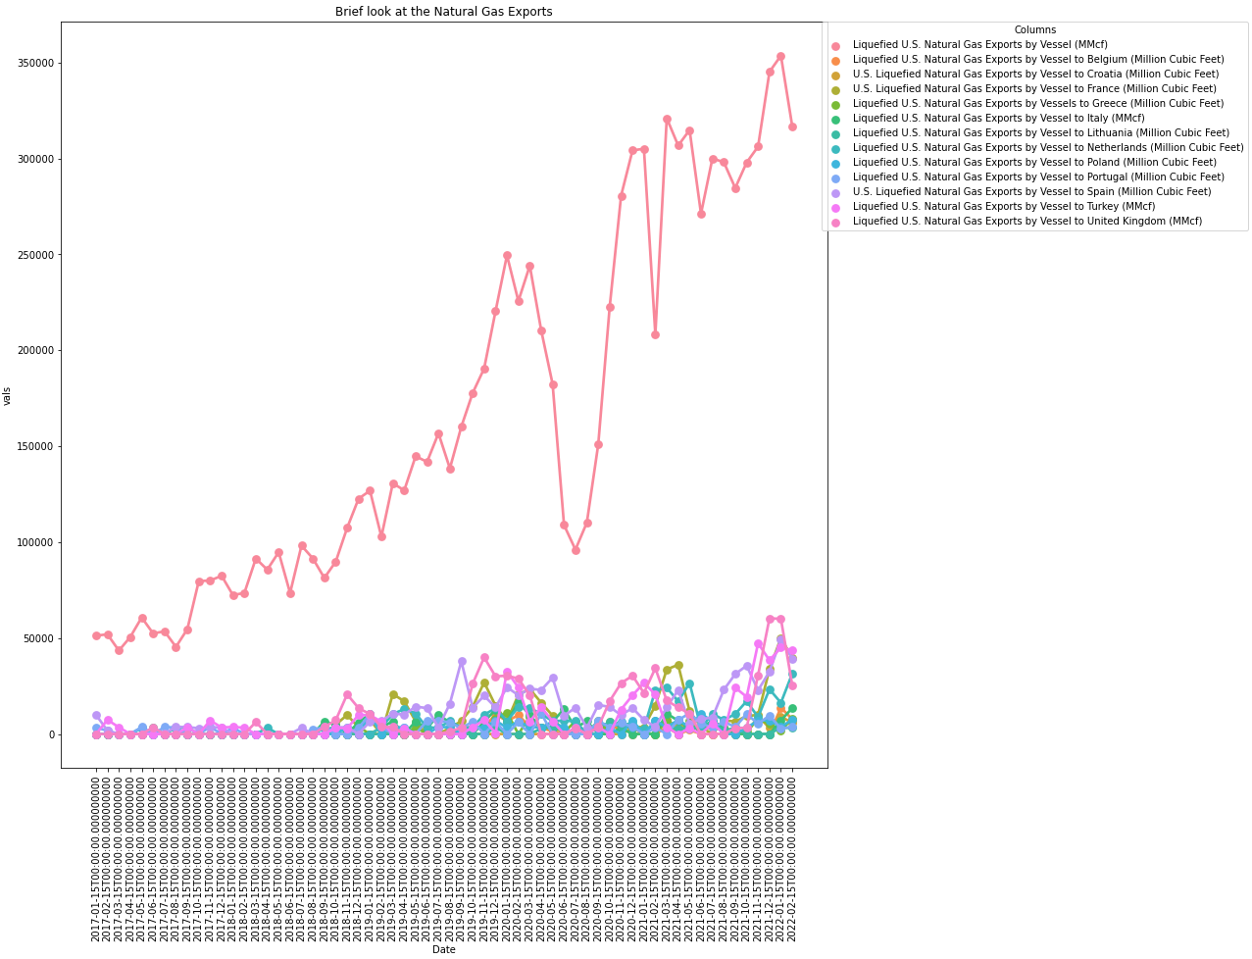

### Image 2

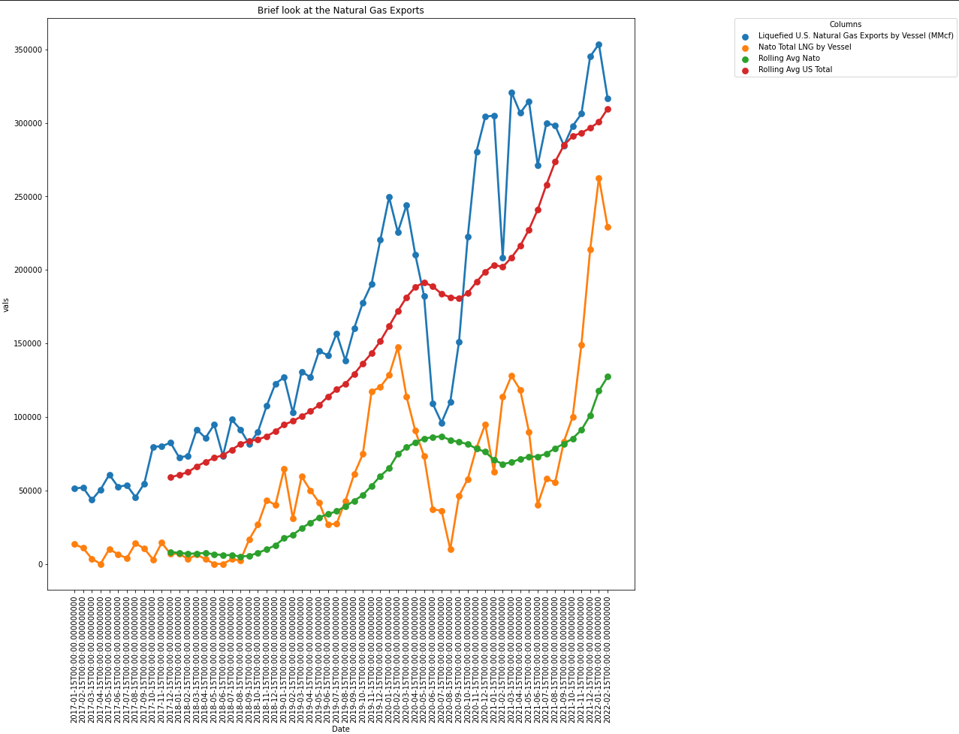

### Image 3

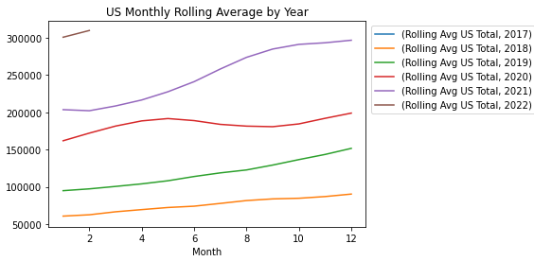

### Image 4

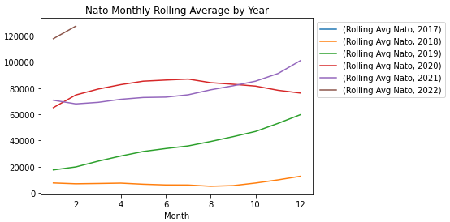

### Image 5: Nato

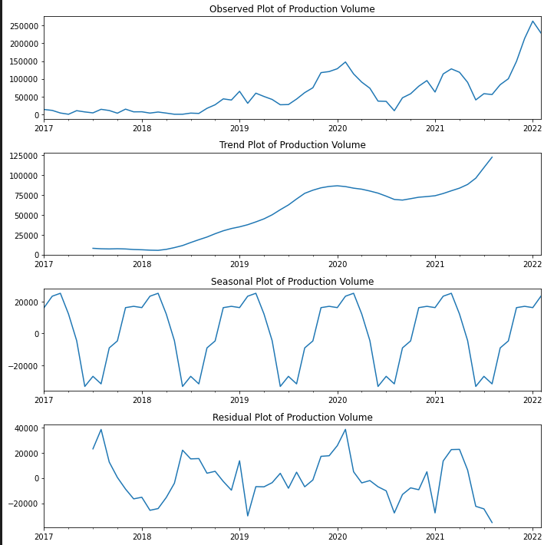

### Image 6

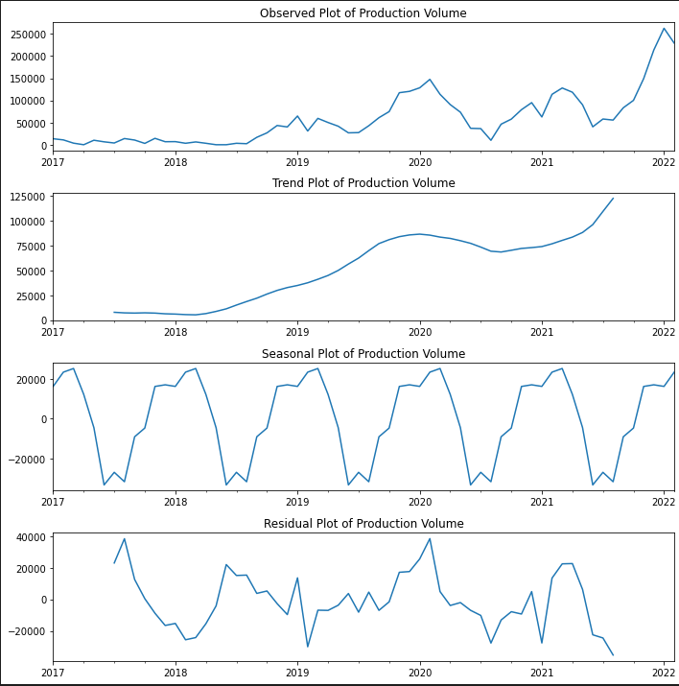

### Image 7

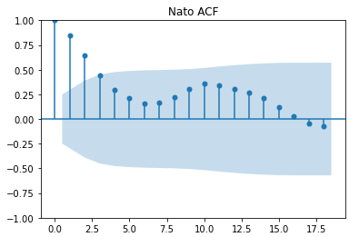

### Image 8

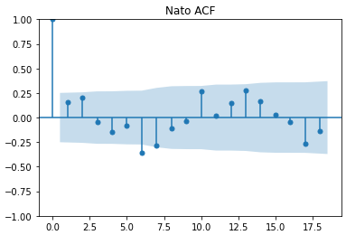

### Image 9

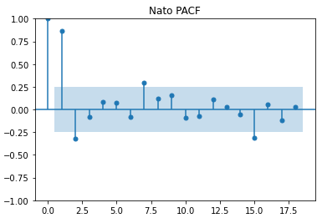

### Image 10

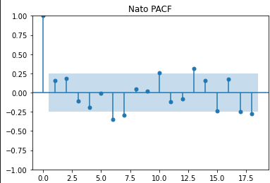

### Image 11

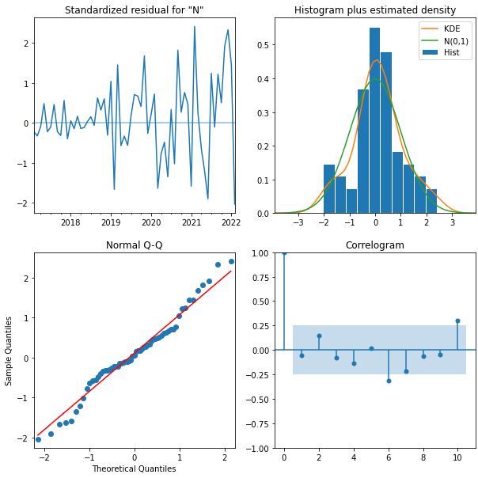

# Bibliography

Anderson, R. J. (2008, September). *Europe's Dependence on Russian Natural Gas: Perspectives and Recommendations for a Long-term Strategy*. Retrieved from George C. Marshall Europen Center for Security Studies: https://www.marshallcenter.org/de/node/1276

*Downloads*. (n.d.). Retrieved from ChromeDriver - WebDriver for CHrome: https://chromedriver.chromium.org/downloads

IEA. (2022, March 3). *A 10-Point Plan to Reduce the European Union's Reliance on Russian Natural Gas*. Retrieved from International Energy Agency: https://www.iea.org/reports/a-10-point-plan-to-reduce-the-european-unions-reliance-on-russian-natural-gas

*LNG Monthly 2022*. (2022, May 16). Retrieved from Office of Fossil Energy and Carbon Management: https://www.energy.gov/fecm/articles/lng-monthly-2022

*Russia's Natural Resources Valued at 60% of GDP*. (2019, March 14). Retrieved from The Moscow Times: https://www.themoscowtimes.com/2019/03/14/russias-natural-resources-valued-at-60-of-gdp-a64800

*U.S. Natural Gas Exports and Re-Exports by Country*. (2022, 5 31). Retrieved from U.S. energy Information Administration: https://www.eia.gov/dnav/ng/ng_move_expc_s1_m.htm

1. (Anderson, 2008)
2. (IEA, 2022)
3. (Russia's Natural Resources Valued at 60% of GDP, 2019)
4. (U.S. Natural Gas Exports and Re-Exports by Country, 2022)
5. (Downloads, n.d.)